USER INTERFACE AND USER EXPERIENCE DESIGN LAB

EXPERIMENT 2

NAME : SUNEEL P V
REG.NO : 23MIS0254
SLOT : L39+L40

Jugaad Design: Study Identify Jugaad things and submit a minimum of 3 to 5 photographs.

Prepare a report mentioning: •
Jugaad concept • Source of photographs Objective To identify innovative "Jugaad" (frugal innovation) solutions used in daily life and understand how simple, low-cost ideas solve practical problems efficiently

VIT MOODLE INFRASTRUCTURE (jugaad design)

In this project, the redesigned Moodle homepage is a Jugaad solution because it does not require changes to the backend or additional hardware. It only reorganizes the user interface by placing the most important features—such as Login, My Courses, Important Announcements, and Upcoming Events—at the top while moving old news to an archive. This simple redesign makes the system easier to use, saves students' time, and improves the overall user experience at a very low cost.

Description

The Smart Moodle Dashboard is a low-cost UI/UX redesign that prioritizes the most frequently used student features. Instead of displaying old site announcements first, it places the Login section, My Courses, Important Announcements, Upcoming Events, and Quick Access options at the top. This improves navigation and helps students access essential information faster without modifying the existing Moodle backend.

Benefits
Faster access to important features.
Reduces time spent searching for courses and announcements.
Improves user experience through better content organization.
Minimizes confusion caused by outdated news.
Increases productivity for students and faculty.

Materials Used
A4 sheet (for paper prototype)
Pencil
Eraser
Scale
Black and colored sketch pens
UI/UX design principles
Moodle interface as the reference

Limitations
It is only a paper prototype and not a functional application.
Requires implementation by the Moodle development team.
User feedback is needed before final deployment.
Existing users may need time to adapt to the new layout.
Does not improve backend performance or server speed.

BAD DESIGN:

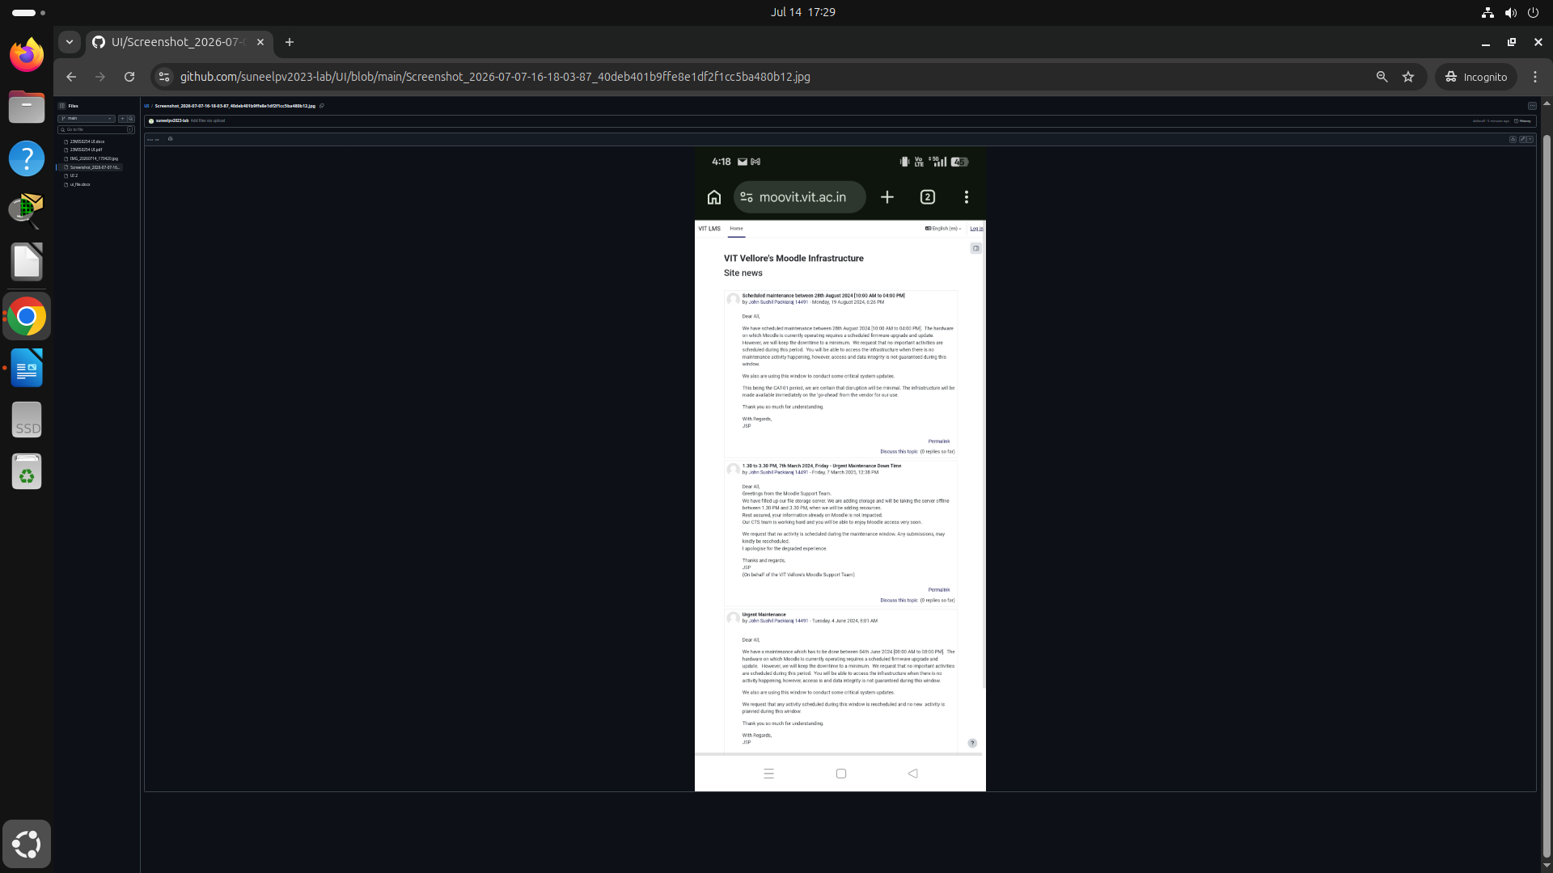

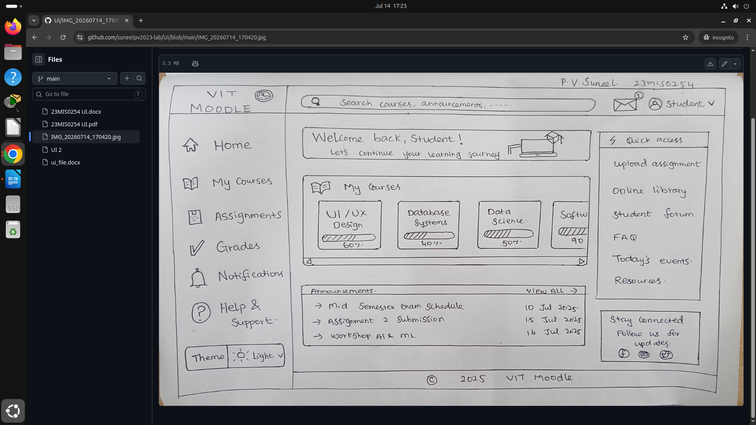
GOOD DESIGN:

